Unique ID Checklist

The following process should be followed to obtain Unique IDs on new employees or to update TEA’s database to show changes to employee information such as name changes.

- Log into TxEIS > Human Resources > Utilities > Texas Unique Staff ID Interface > Staff ID Export tab. Enter the current school year information (if not already populated) and Execute. A preview of staff members who do not currently have a Unique ID will be displayed. Select Process to create the file to send to TEA.

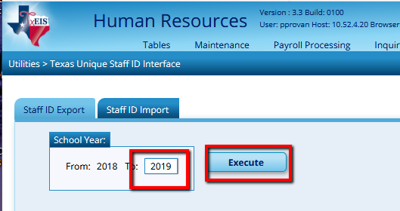

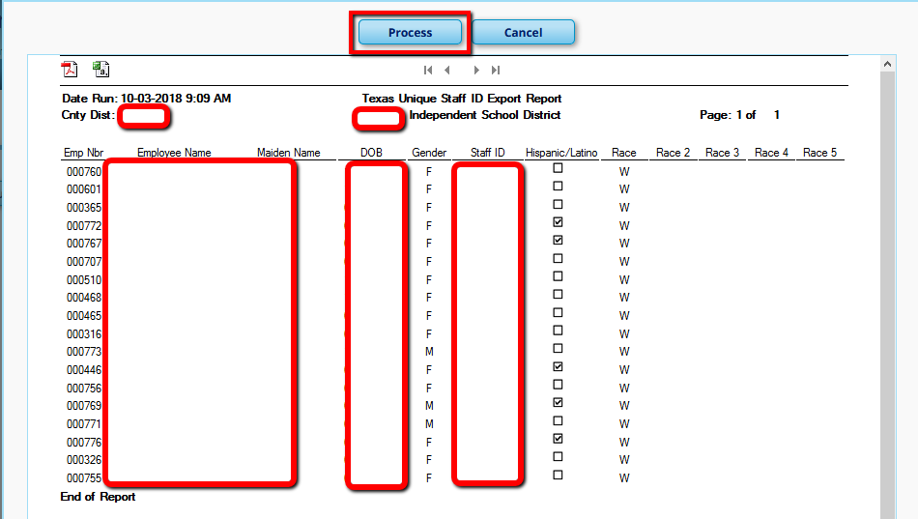

Select the location to save your file to and Save. DO NOT CHANGE THE FILE NAME. You will get a message indicating your file was successfully created.

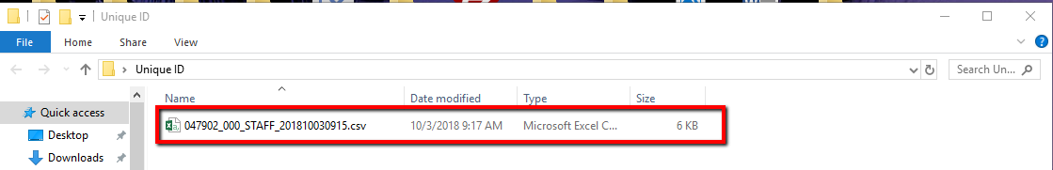

- Log into TEAL and accept the privacy statement if one is displayed. This will have to be selected again every 30 days so it may feel like you have to accept one nearly every time you log in.
Here is a link to TEAL: https://pryor.tea.state.tx.us

- From there, choose the Texas Student Data System Portal and then click on the Manage Unique ID logo.

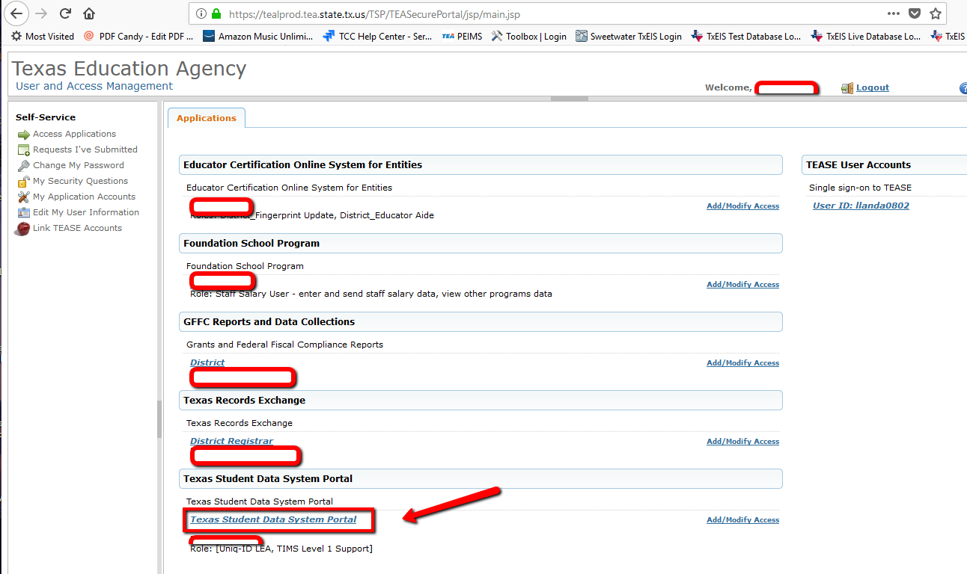

- Select the three horizontal lines in the upper left corner to display the menu.

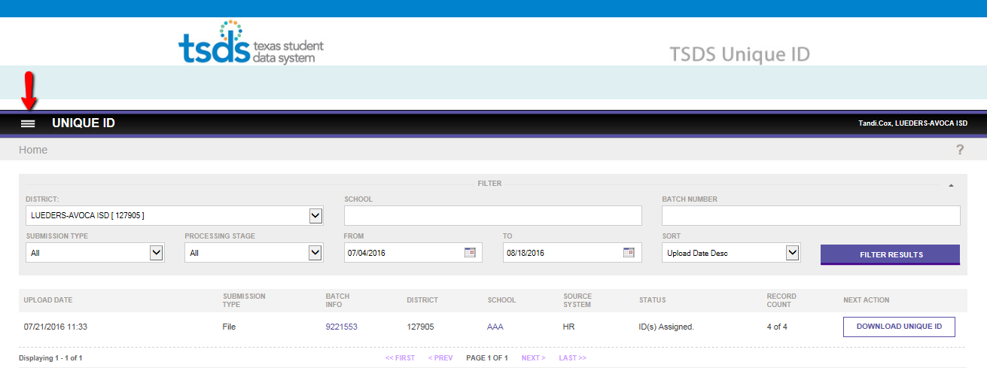

- Select: Assign > Upload file.

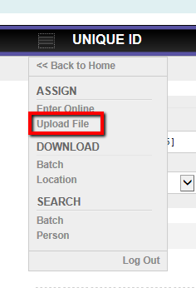

- Browse to find the file you just saved from TxEIS then click Upload.

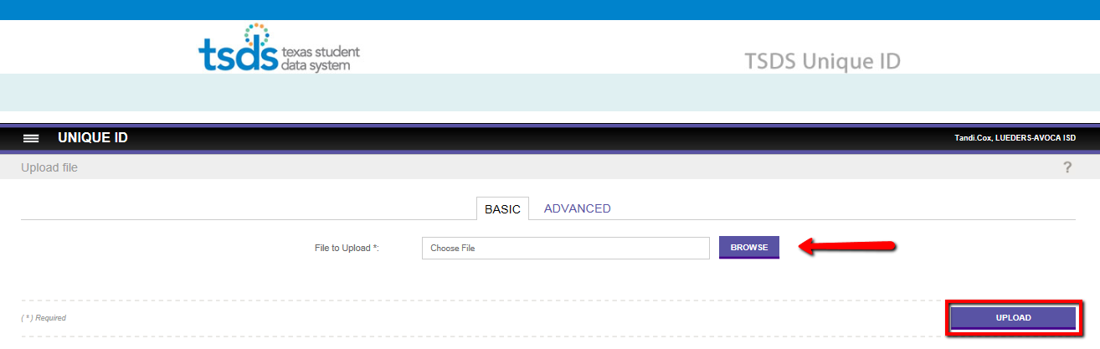

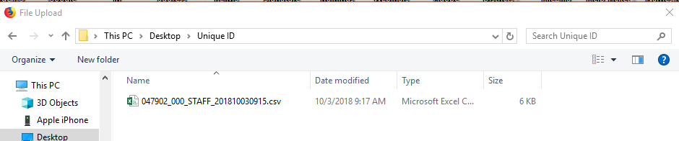

- Note the batch number that is assigned to your file in the Batch Info column in case there are several files being processed. (Student files are also sent here, so there could be multiples.)
- The status will show that Data Validation is in progress.
- Click the Back to Home button on the far right.

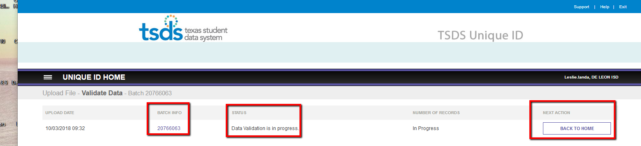

- On the Home page
- Verify your Upload batch has uploaded.
- Click the Assign Unique ID button to the right of your batch file.

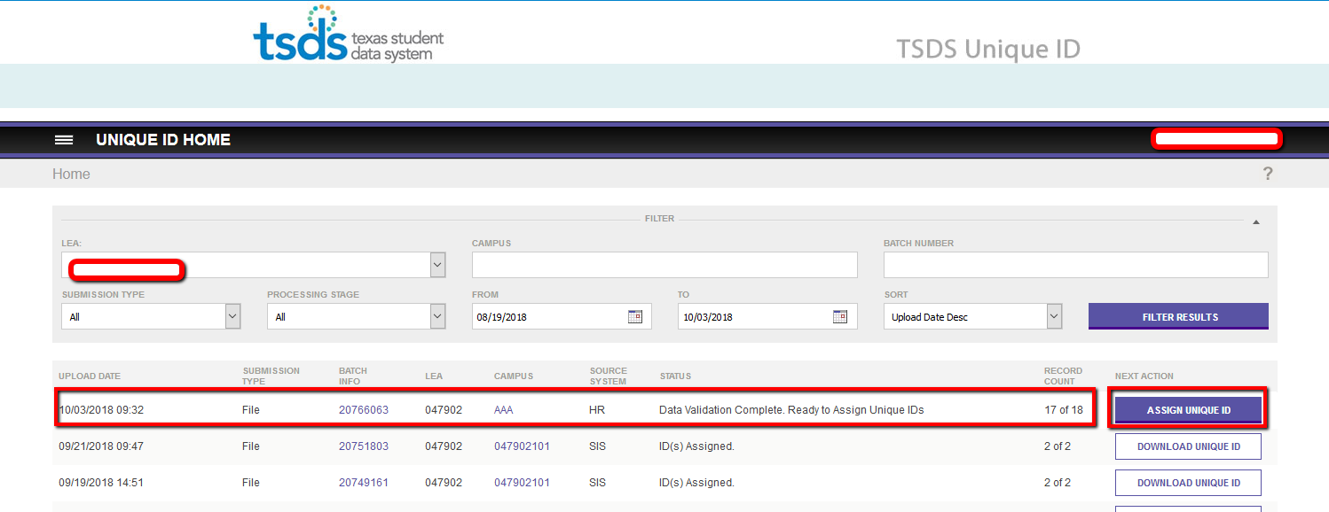

- The status should now show ID Assignment is in progress.
  - Click the Back to Home button again to check its progress.

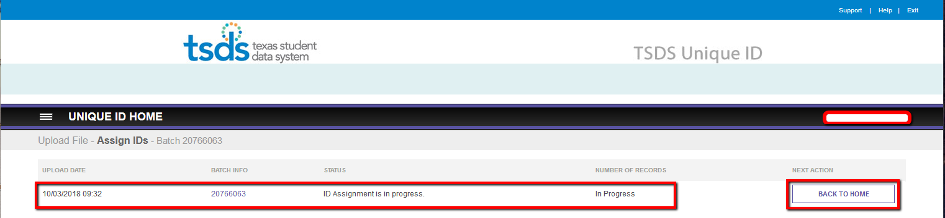

- You may have to refresh the Home page a few times if you have a large file or several districts are trying to hit the server at once.
  - We are looking for a new button in the Next Action column. If the button says Resolve Near Matches, complete this step.
  - If it says Download Unique ID, you may skip to step 15. Otherwise, click on the Resolve Near Matches button.

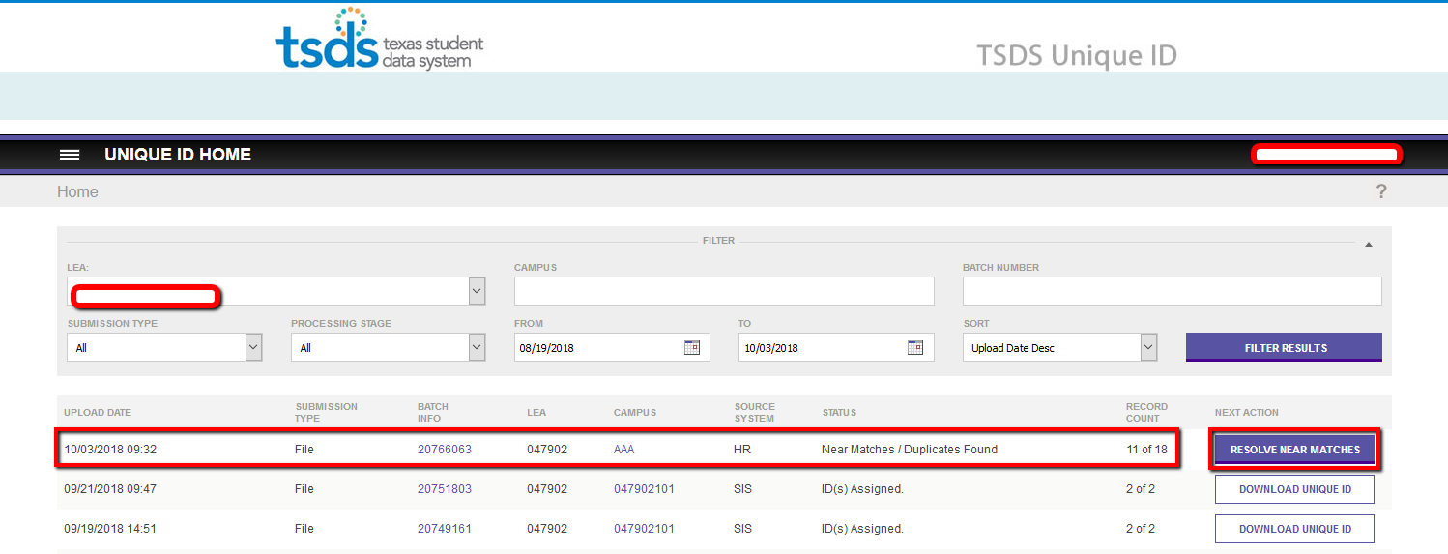

- All Near matches must be resolved. To resolve, click on the first employee’s name.

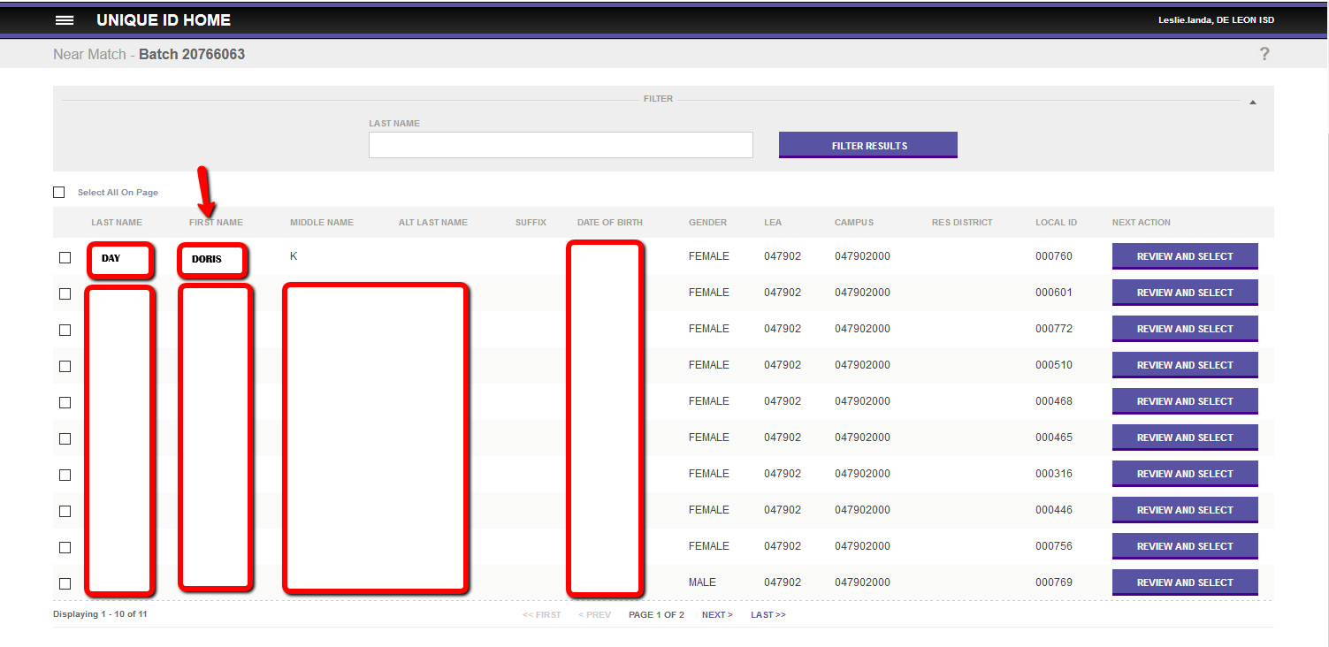

- On the following screen, Click on the first name of each possible match in the bottom section.
- Most will have only one name listed
- If more than one is listed, check each one to determine the best possible match. If you determine there are two records that actually reflect the same person, please contact Liz Hatch to get that resolved.

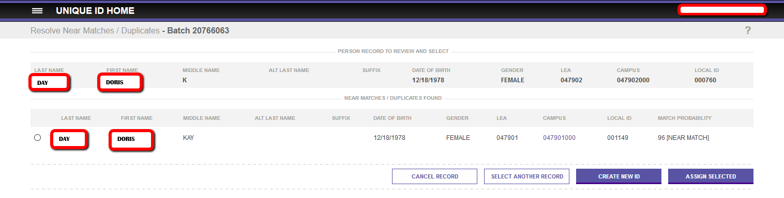

- Clicking on the name will bring up a screen that compares the data currently held in the PID database at TEA to the information you have in TxEIS.
  - The information in the center column under Submission Record reflects what is displayed in TxEIS.
  - The information on the far right is what is currently in TEA’s PID database.
  - Review to determine which side is accurate.
  - Information that differs in highlighted in a yellow/orange color. The information from TxEIS (center column) should be correct.

Differences
- In our example, the TEA database (far right column) shows a middle name of KAY. TxEIS (middle section) has the middle initial of K.
- Other differences have to do with her moving from one District to our District, so we know we want that updated.
- Assuming the info in TxEIS is correct, select the Yes radio button near the bottom to Update Master and click Assign Selected. This will Update TEA’s records to reflect the new information on that employee, such as a name change, and will resolve the near match so an ID can be assigned.
- If the information of an employee has Student (TEA Side) with a Unique ID becoming a Teacher, you will Update Master with Yes and then Assign Selected.
- If the information on TEA’s (far right side) is correct, (which our example shows):
  - Click on Cancel Record
  - Return to TxEIS and Verify and Correct the information.
  - Export the Unique ID file again. Go through all the steps again until you come to the Compare Records. You will then be able to Yes to Update Master and Assign Selected.

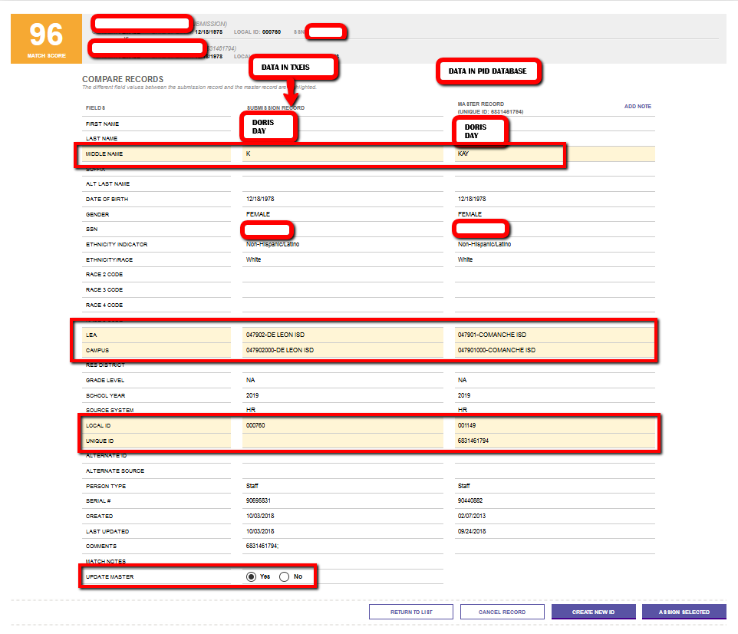

NOTE 1: If you determine that the person being compared is a completely different person, select the Return to List of Near Matches button to check the next possible match in the list at the bottom of that screen.

NOTE 2: If you have reviewed all possible matches and believe this is a totally new employee to the system, please call Karen E Turner or Liz Hatch for assistance. Please do not select the Create New ID button without talking to Liz or Karen first as selecting this button incorrectly creates a hardship on TEA and it is difficult to correct.
- Once you have resolved the near match on this employee, continue in the same manner until all matches are resolved.

- Once all Near Matches have been resolved, select the Download Unique ID button to the right of your batch number.

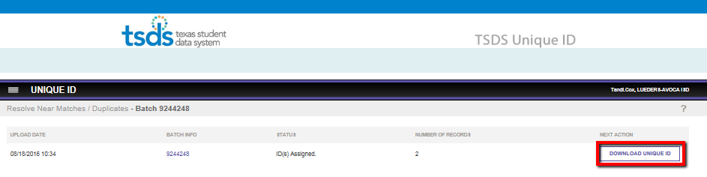

Click the Download button to obtain the file that contains Unique IDs for all new employees.

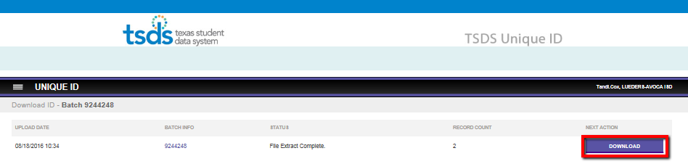

- Save the file to the desired location. Note the new file is named sid_CCCDDD_000_Staff……

- Import the new data into TxEIS by logging into TxEIS > Human Resources > Utilities > Texas Unique Staff ID Interface > Staff ID Import tab. Browse to find the file in the previous step and Submit.

- Execute and Process the Preview.

This will populate the Texas Staff Unique ID in the Staff Demo field for you.

If you have questions or concerns, please call your TxEIS Consultant for assistance.

